NEET 2021

1. Match column –I with column – II :

|  |  |
| --- | --- |
| Column-I | Column-II |
| (a) Nitrococcus | (i) Denitrification |
| (b) Rhizobium | (ii) Conversion of ammonia to nitrite |
| (c) Thiobacillus | (iii) Conversion of nitrite to nitrate |
| (d) Nitrobacter | (iv) Conversion of atmospheric nitrogen to ammonia |

Choose the correct answer from the options given below:

1. (a)-(iii); (b)-(i); (c)-(iv); (d)-(ii)
2. (a)-(iv); (b)-(iii); (c)-(ii); (d)-(i)
3. (a)-(ii); (b)-(iv); (c)-(i); (d)-(iii)
4. (a)-(i); (b)-(ii); (c)-(iii); (d)-(iv)

Answer: c. (a)-(ii); (b)-(iv); (c)-(i); (d)-(iii) [Refer page 201; Section 12.6.1; (NCERT 2021-22)]

NEET 2020

1. The product(s) of the reaction catalyzed by nitrogenase in root nodules of leguminous plants is/are:
2. Nitrate alone
3. Ammonia and Oxygen
4. Ammonia and Hydrogen
5. Ammonia alone

Answer- c. Ammonia and Hydrogen [Refer page 203; Section 12.6.2; (NCERT 2021-22)]

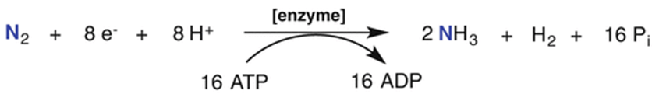

[where, enzyme= nitrogenase]

1. Match the following concerning essential elements and their functions in plants:

|  |  |
| --- | --- |
| 1. Iron | 1. Photolysis of water |
| 1. Zinc | 1. Pollen germination |
| 1. Boron | 1. Required for chlorophyll biosynthesis |
| 1. Manganese | 1. IAA biosynthesis |

Select the correct option:

1. (a)-(iv); (b)-(iii); (c)-(ii); (d)-(i)
2. (a)-(iii); (b)-(iv); (c)-(ii); (d)-(i)
3. (a)-(iv); (b)-(i); (c)-(ii); (d)-(iii)
4. (a)-(ii); (b)-(i); (c)-(iv); (d)-(iii)

Answer- b. (a)-(iii); (b)-(iv); (c)-(ii); (d)-(i) [Refer page 197-198; Section 12.2.2; (NCERT 2021-22)]

1. In Glycine max, the product of biological nitrogen fixation is transported from the root nodules to other parts as:
2. Ammonia
3. Glutamate
4. Nitrates
5. Ureides

Answer- d. Ureides [Refer page 204; Section 12.6.2; (NCERT 2021-22)]

1. Which of the following elements helps in maintaining the structure of ribosomes?
2. Magnesium
3. Zinc
4. Copper
5. Molybednum

Answer- a. Magnesium [Refer page 197; Section 12.2.2; (NCERT 2021-22)]

NEET 2019

1. Thiobacillus is a group of bacteria helpful in carrying out:
2. Denitrification
3. Nitrogen fixation
4. Chemoautotrophic fixation
5. Nitrification

Answer- a. Denitrification [Refer page 201; Section 12.6.1; (NCERT 2021-22)]

1. Which of the following bacteria reduce nitrate in soil into nitrogen?
2. Nitrobacter
3. Thiobacillus
4. Nitrococcus
5. Nitrosomonas

Answer- b. Thiobacillus [Refer page 201; Section 12.6.1; (NCERT 2021-22)]